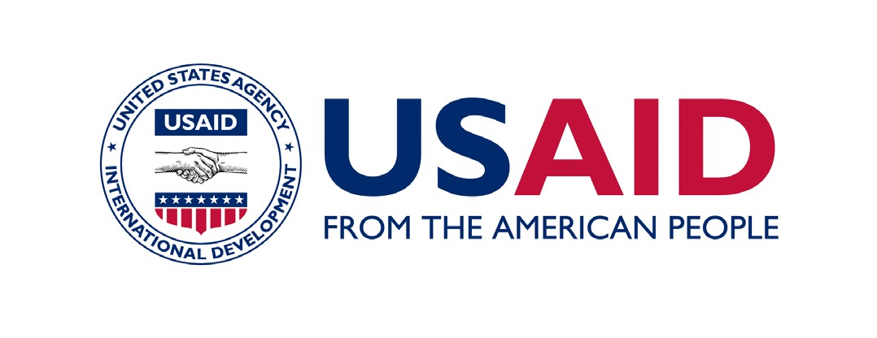

OCTOBER 2015

GEMS FACTSHEET

ENVIRONMENTAL PROCEDURES BEST PRACTICES REVIEW
FOR USAID MISSIONS IN AFRICA

HOW HAS THE BEST PRACTICE REVIEW (BPR) CHANGED?
The BPR documents and communicates the environmental compliance procedures, successes, and needs throughout the entire program life cycle.
The BPR process has been revised in accordance with Agency guidance to account for the new operating realities of USAID, particularly in relation to the increased use of sub-obligations, focus on working through host country systems, and reliance of locally-sourced solutions and institutions. Additionally, the BPR has been expanded to include both Mission-funded, Africa Bureau-funded, and other Bureaus that fund activities in Africa, and centrally-funded mechanisms since environmental compliance responsibilities for both fall to some extent within the responsibilities of the Mission.

Photo: Scott Dobberstein/ USAID/Sahel

WHAT ARE USAID’S ENVIRONMENTAL PROCEDURES?
USAID’s Environmental Procedures are required by court order, executive order, and statute to utilize an Environmental Impact Assessment (EIA) process. Pre-implementation requirements are set out in Federal regulations 22CFR216 (or “Reg. 216”) and USAID’s Automated Directives System (ADS). The ADS defines the process and follow-through requirements for project implementation, particularly ADS 204. Environmental requirements for the program life cycle are further defined in ADS 201.3.16. They were established and are used to mitigate adverse environmental and social impacts of USAID activities and to promote environmental sustainability.
Compliance with these procedures is mandatory. They apply to every program, project, activity, and amendment supported with USAID funds, including instruments which directly obligate or sub-obligate program or operating expense funds. Besides traditional development assistance, these also include partial loan guarantees, government to government (G2G) agreements, bilateral, and trilateral agreements.
Procedures are applied throughout the life of a project with reviews beginning at the early concept stage and carried out through monitoring and reporting until project closeout. Direct, indirect, cumulative and social impacts are considered during this process.

In summary, USAID’s environmental procedures require that:
- Environmental considerations are taken into account in activity planning/early design.
- Prior to implementation, all activities undergo a formal EIA process defined by 22 CFR 216. This process is documented in 22 CFR 216 documentation and must be duly approved by the Mission Director (or equivalent) and the Bureau Environmental Officer.
- Environmental mitigation and monitoring conditions resulting from this EIA process are written into procurement instruments (contracts, awards, cooperative agreements, etc.), implemented, and monitored.
- Operating units must report annually on the environmental compliance status of each project in their portfolio.
- Environmental compliance documentation is maintained and used to actively manage implementation.
- Per Executive Order 13677, all international programs systematically factor climate-resilience into all procedures and activities, including USAID environmental procedures.
Consistently and effectively applied, the procedures strengthen development outcomes and safeguard ecosystems, environmental resources, human health and welfare, and USAID’s reputation.

WHAT IS AN ENVIRONMENTAL PROCEDURES BEST PRACTICES REVIEW?
Its goal is to improve the effectiveness of Mission compliance with USAID’s Environmental Procedures, to better integrate compliance into Mission operations, and to regularly update progress on previous audits and BPRs. Its goal is to improve the effectiveness of a Mission’s and the pillar Bureau’s projects compliance with USAID’s Environmental Procedures, and to better integrate compliance into Mission operations. The BPR also serves as a communication tool between the Mission and the Bureau Environment Officer in Washington, DC on environmental compliance highlights and needs.
Inter alia, the BPR assesses:
- The presence and quality of the required Reg. 216 environmental documentation;
- The establishment of roles and responsibilities and reporting lines;
- The adequacy of Mission staff and partner capacity to implement the procedures and whether staffing and training needs have been identified and plans made to address them;
- The integration of environmental compliance into Mission processes;
- Mission resources internally and to assist partners in environmental compliance;
- Updates needed on implementation of the previous BPR Action Plan or on Office of the Inspector General’s (OIG) Audit recommendations.

WHY SHOULD A MISSION CONDUCT A BPR?
Experience shows that USAID often does not consistently or effectively apply its Environmental Procedures over the full project lifecycle. Among others, common gaps in compliance include:
- Failure to develop and implement Environmental Mitigation and Monitoring Plans (EMMPs) that are responsive to the Initial Environmental Examination (IEE) conditions
- Lack of consistent review of project activities on a regular basis to ensure that they are still within the scope of the IEE
- Challenges in monitoring and implementing Pesticide Evaluation Reports Safer Use Action Plans (PERSUAPs)
- Development Objective-level IEEs that inadequately address the specific activities being implemented or are too broad to apply conditions to specific activities
- IEEs or Environmental Assessments (EAs) with conditions (i.e., mitigation measures) that are not being implemented, monitored, or reported on;
- Procurement instruments that fail to incorporate environmental compliance requirements
The BPR identifies any such gaps and recommends corrective measures. Experience from the past shows that BPRs make a difference. By the beginning of 2014, all African Missions have completed at least one BPR along with Action Plans based on those recommendations. Over the course of these reviews, many non-compliance issues have been corrected, and improved practices and processes to ensure compliance were implemented. Partners and Mission staff received additional training on their roles and responsibilities, and staff renewed the mandate to carry out that authority. Additionally, the BPRs provided a vehicle for Missions and Bureaus to periodically report on their progress toward recommendations in the OIG’s Audit on Mission’s Efforts to Mitigation Environmental Impact of Project Portfolios and country-level audits.
It is important to conduct internal BPR reviews and/or follow-ups at least once a year. BPRs are voluntary and are undertaken at a time chosen by the Mission and Bureau; however, as part of its response to the OIG’s global environmental compliance audit, AFR Bureau has committed that all AFR Missions will undertake a BPR at least every 5 years.

WHAT IS THE BPR METHODOLOGY?
The BPR is initiated by the Mission and Bureau, but is conducted by an external facilitator, a Mission counterpart (the Mission Environmental Officer (MEO) or designee), and the Regional Environmental Advisor/Officer (REA/O), who participates for at least part of the in-Mission segment. The BPR reviews typically employ the established template and survey questionnaire.
While the process can be adapted to meet Mission needs, it consists of three parts:
- Review of key documentation from the Mission/Bureau and partners
- Interviews with Team Leaders, Agreement/Contracting Officer’s Representatives (A/CORs), Program Officers, Contracting/Agreement Officers, Legal Advisors, and other key Mission staff
- Field visits to observe implementation, tracking, and reporting at the Mission level to verify findings of the desk study and interviews
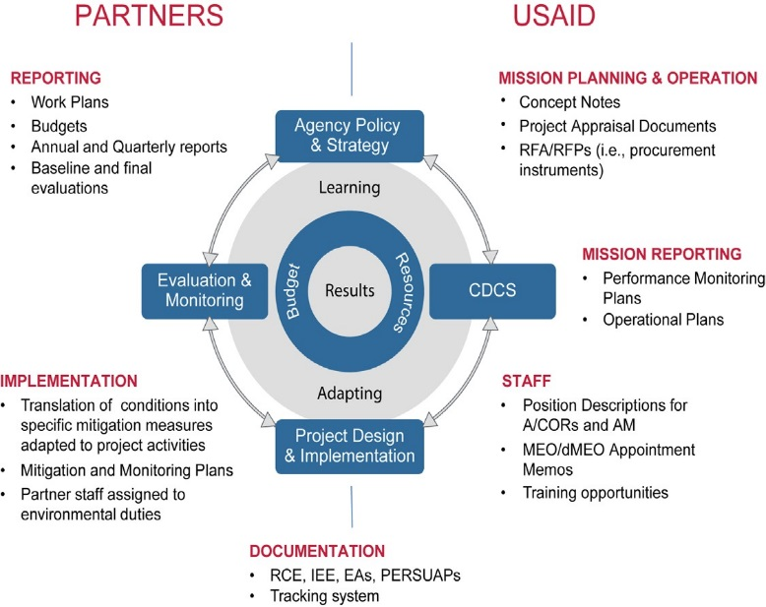
The documents and items reviewed in the BPR are summarized in the diagram below.

For a typical bilateral Mission, the BPR requires approximately 22 working days for the BPR facilitator, excluding any international transit, plus a limited level of home office technical, administrative and production support. Nominally*, this level of effort is distributed as follows:
- 5 days for desk review of Mission documents and advance correspondence;
- 4 days for a first in Mission segment, including in brief and first round interviews with all sector teams and target partner staff in the capital.
- 5 days site visits (usually over a working weekend)
- 3 days for a second in-Mission segment, including wrap-up interviews and development and briefing of draft findings
- 5 days remote desk work to produce a draft and revised Report and Action Plan
*REA/O support may shorten this time; remote sites and large/complex portfolios may extend it.
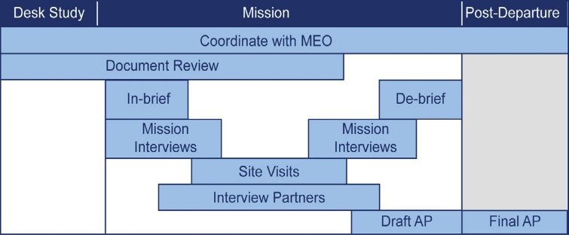

WHAT IS THE MISSION AND PARTNER ROLE IN THE BPR?

MEO OR MISSION/BUREAU DESIGNEE
The MEO or designee is the primary contact at the Mission/Bureau responsible for the BPR. Their involvement is key to the success of the activity. Specific responsibilities include:
- Collecting documents for desk review and transmit to facilitator
- Establishing an interview schedule with Mission staff and participating in meetings
- Facilitating approvals for access to the Mission, partners and host country agencies with official introductions where needed
- Coordinate G2G meetings and field visits

MISSION STAFF
Ideally, USAID staff receives a 1 hour refresher on USAID Environmental Procedures followed by a 1 hour in-brief on the BPR processes. Over the following days, the BPR team will spend about 1 hour interviewing each sectoral team and schedule separate, follow-up interviews of about 1 hour for with key team members depending on the significance of the environmental mitigation and monitoring responsibilities under their programs. In addition, the team will typically interview Program Officers, M&E Specialists, and Procurement or Contracting Officers, Legal Advisors, and others as appropriate. Pertinent A/CORs will be requested to attend site visits.

PARTNERS
Selected partners will be identified for interviews, EMMP reviews, refresher trainings and field visits. They will be responsible for assisting the BPR Team with the scheduling of these activities. Typical BPR Teams work with 5+ partners.

WHAT ARE THE OUTPUTS OF THE BPR?
At the end of the BPR, the facilitator will draft a BPR Report and Action Plan (AP) that documents strengths and gaps in Mission and partner compliance process against the BPR standards, including changes since the previous BPR, and recommended actions to address gaps. The document can serve as a means for communicating needs and specific compliance requirements to Mission staff and partners and should be reviewed annually.
ARE MISSIONS REQUIRED TO IMPLEMENT BPR ACTION PLANS?
The Mission is required to correct non-compliance situations. Other recommendations made in the BPR AP are intended to strengthen Mission environmental compliance to make it a more systematic and integrated process, and in so doing, strengthen development outcomes and reduce the possibility that well-intentioned activities could result in adverse impact on beneficiaries or environmental resources.

WHAT RESOURCES ARE AVAILABLE TO ASSIST WITH BPRS?
The following resources are available to help Missions implement the BPR process and to minimize the burden on Mission staff:
Regional Environmental Advisor/Officer (REA/O) Support. REA/Os participate in at least part of the in-Mission segment of all BPRs. They may also be available to provide BPR coordination or additional technical support.
AFR/SD GEMS Technical Support. Africa Bureau’s GEMS Team (www.usaidgems.org) is available to provide BPR facilitators and technical assistance to support Action Plan implementation. GEMS resources are typically provided on a Mission cost-share basis. GEMS support is accessed via request to the REA.
Other External Resources. GEMS support is NOT required to conduct a BPR. Using its own resources, the Mission/Bureau may contract directly with a consultant to serve as the BPR facilitator and to provide TA to implement the AP. Ideally, such support would be local and therefore more available for follow-up support.
AFR/SD and GEMS can help identify international consultants, as needed, and can provide assistance with a Scope of Work.

ACRONYMS
A/COR Agreement/Contracting Officer’s
Representative
ADS Automated Directives
System
AFR USAID Bureau for Africa
AP Action Plan
BPR Best Practice Review
dMEO deputy Mission Environmental Officer
EA Environmental Assessments
EIA Environmental Impact Assessment
EMMP Environmental Mitigation and Management Plan
ESDM Environmentally sound design and management
G2G government to government
IEE Initial Environmental Examination
MEO Mission Environmental Officer OIG Office of Inspector General’s
PERSUAP Pesticide Evaluation Report Safer Use Action Plan
RCE Request for Categorical Exclusion
REA/O Regional Environmental Advisor/Officer
RFA/P Request for Application/Proposal
The key output of the BPR is the BPR Report and Action Plan which provides the results of this assessment and sets out recommended actions to address key gaps in compliance and compliance capacity.

Executive Order 13677-- Climate-Resilient International Development actions of September 23, 2014.
http://oig.usaid.gov/sites/default/files/audit-reports/9-000-11-002-p.pdf
Bureau for Africa (AFR) Environmental Compliance Best Practice Standard, A Practitioner’s Template
Best Practice Review, Survey Questions for Practitioners
Image reference: USAID, ADS 200.

